Introduction

Most of us would know that we can password protect a BI Publisher Report output and can even make the password static (fixed value) or dynamic based on any of the data attribute used in the Data Source of the Data Model. But I guess most of us are not aware that one can even do a password protection for an OTBI Output too.

We will demonstrate the same in this post.

Pre-Requisite

We must have a pre-existing report which should have its data source as “Subject Area”. We have such a report named ‘PersonBasicDetailsReport’ and the Report Output is as below:

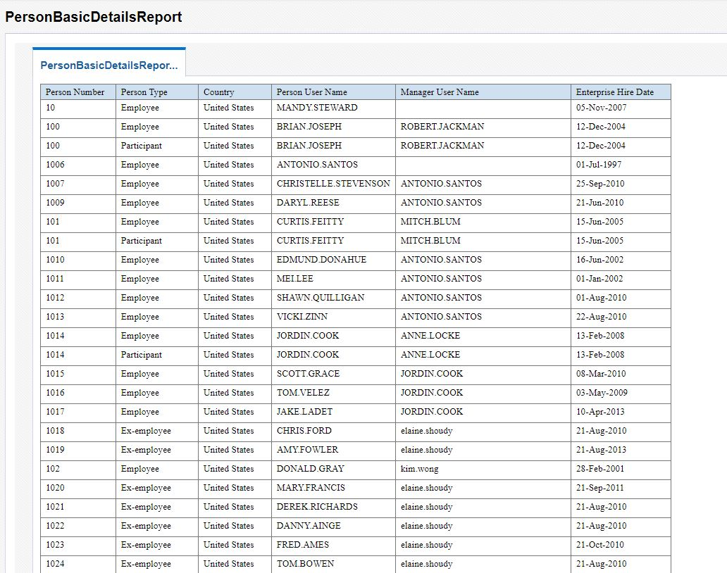

Add Password Protection to the Report (Output Type – PDF)

Now we will try to ensure that we password protect this file whenever the output type is PDF. We can do so by making some setting changes under the ‘Properties’ tab of the Report under ‘Edit Report’ .

***Navigation: Edit Report->Properties->Formatting->PDF Output***

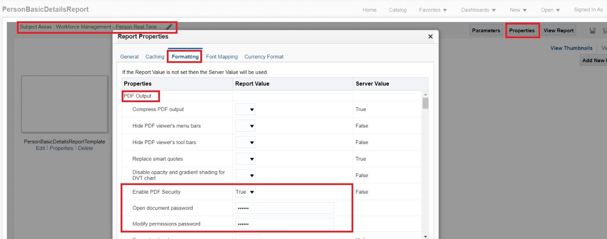

Add Password Protection to the Report (Output Type – EXCEL 2007 Output)

We can also make similar settings for Excel Output too.

***Navigation: Edit Report->Properties->Formatting->EXCEL 2007 Output***

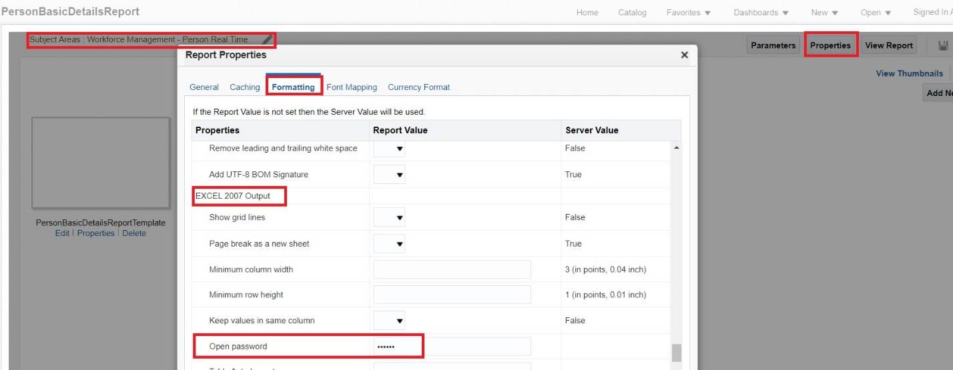

Verification

Now that the setup part is complete we will try to run the report in PDF and Excel and see if its prompts for a password.

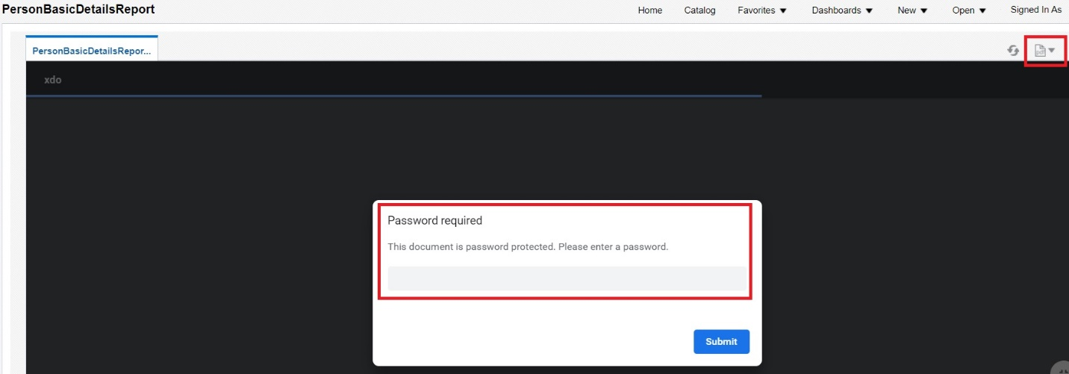

Now, if we change the output type to ‘exl’ then also we will asked for a password.

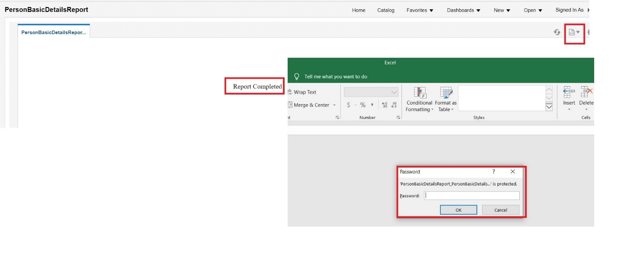

Summary

So this is how we can password protect output generated from OTBI Analysis .

Hope this was useful.

Thanks all for your time and have a nice day ahead.